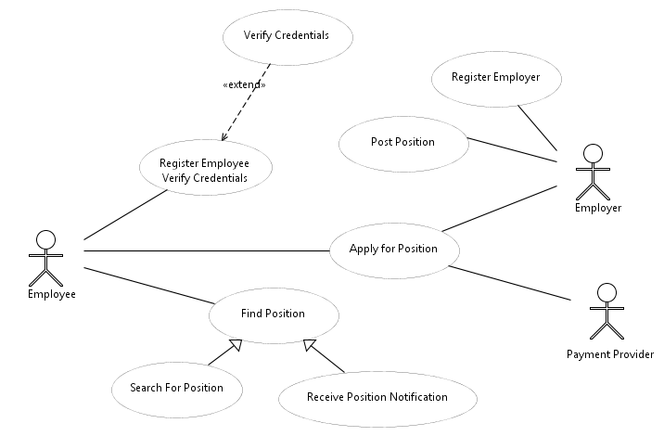
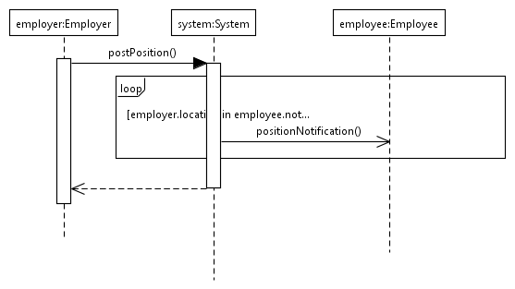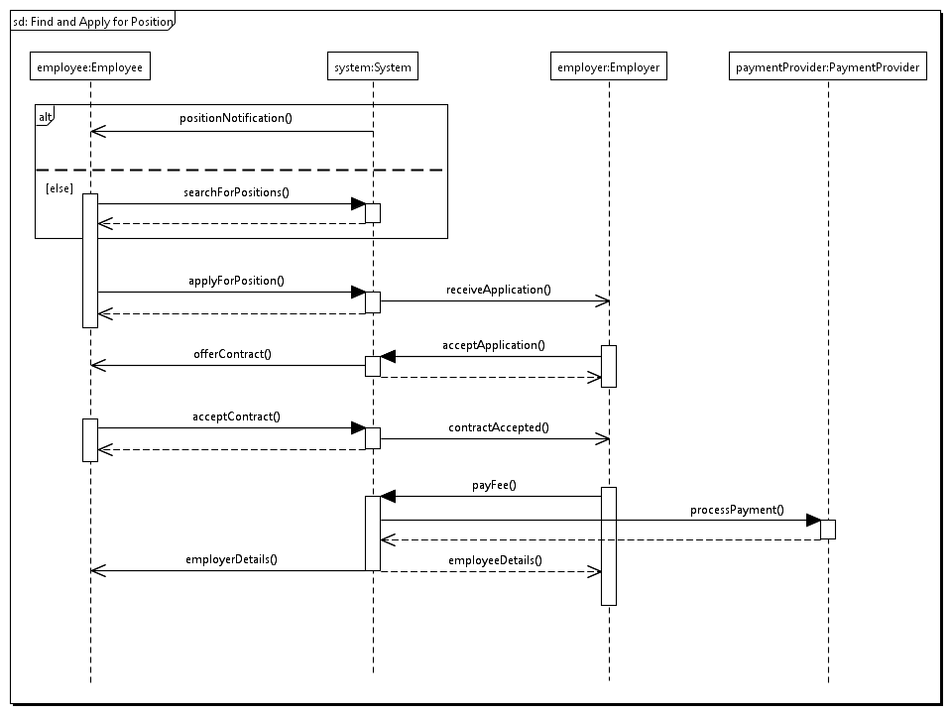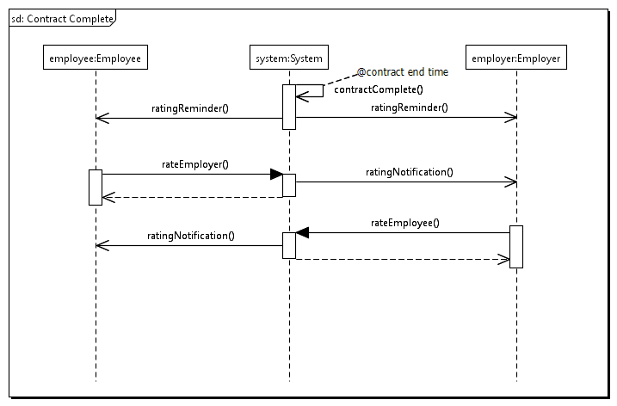

Site map

General
- Home
- Search positions
- Position Search results
- View position
- T&Cs
- Contact Us
- About Us
- Create profile (for applicant, for employer)

Logged in Applicants
- Edit profile
- Apply for position
- View current applications
- View application history
- Per application:
  - View employer profile
  - View application
  - Edit application
  - Accept contract
  - View accepted contract
  - Leave feedback
- Work diary

Logged in Employers
- Edit profile
- Add/remove site
- View sites
- Per site (as site manager):
  - Edit site
  - Post position
  - View current positions
  - View position history
  - Per position:
    - Edit position
    - View applications for position
    - Per application:
      - View application
      - View applicant profile
      - Offer contract
    - View accepted contact
    - Leave feedback
- View invoicing
- Payment

